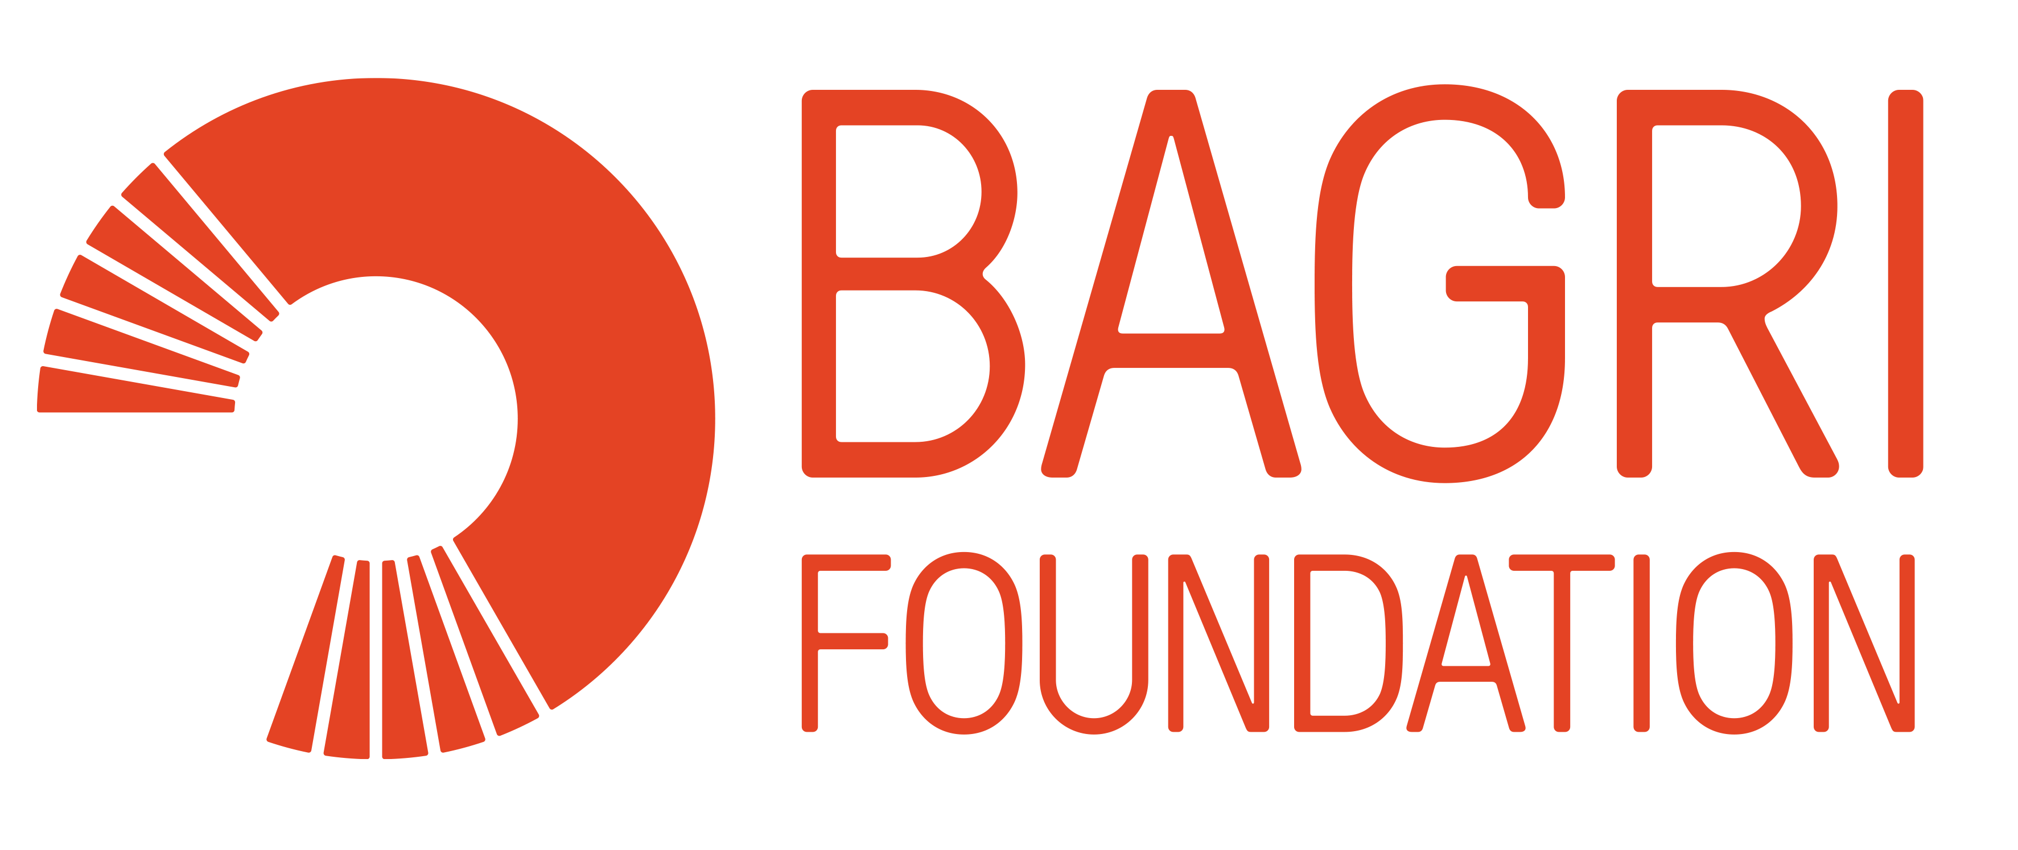 | Received by Bagri Foundation  (For the Foundation use only)

DETAILS

Name of grantee organisation or partner ……………………….……………………………….………………………………………………
Name of the person filling in this form……………………………….……………………………….…………………………….…….…….….
Relevant Email ….....................................................................................Phone contact ….............................................
Date of submission……………………………………….……………………………….……………………………….……………………….…….….
Project dates (start – end date) ………………………………………………………………………….…………………………………………….

EVALUATION

- Please provide a summary of what was accomplished by the project (max. 1,000 words).

- In a single statement, which was the biggest success or outcome in your project? (max. 150 words).

- Please mention any ways in which your organisation has developed as a result of this project (Have you developed new skills, has the project been of benefit to your organisation’s reputation or credibility, has the project created new opportunities for you as organisation?) (max. 1,000 words).

- Has our support enabled you to secure any other funding or forms of support? (max. 500 words).

- What strategies have you used throughout the project to engage different audiences and participants? (max. 1,000 words).

- Please provide in-person audience numbers (if applicable)

- Please provide digital audience numbers (if applicable)

- How did you measure the impact of the project? Is it the curatorial content, the outreach, third-parties reviews? Please define accordingly (max. 500 words).

- What sort of impact has this project had, and what sort of impact do you think it will have in the future? Think of impact on the heritage/art itself, on local communities, and on local, regional, national or international government organisations working in relevant fields? (max. 1,000 words).

- Was there anything that did not work as planned? Which were the lessons learned? (think of what advice we could share for other future applicants of our funding and partnership programme) (max. 500 words).

- What is the future/legacy of your project? How will the outcomes of your project be made publicly accessible? (What will happen now that our support has reached a conclusion?) (max. 500 words).

- Please share with us any further comments or thoughts you and your team might have.

FINANCIAL
Please report on the financial aspects of the project, indicating how the money was spent, and attaching any available relevant documentation (max 500 words). Please attach a project budget against actual cost.

DOCUMENTATION
Please provide a link to photographic documentation demonstrating what the project achieved. Photographs should be high resolution images and accompanied by credits, and be shared with The Bagri Foundation on the understanding that they can be used for publicity purposes.

SOCIAL MEDIA AND PRESS
Please provide a link to a report on any social media activity or press coverage linked to this project and attach relevant material if it exists.

Signed: …………………………………………………….

